

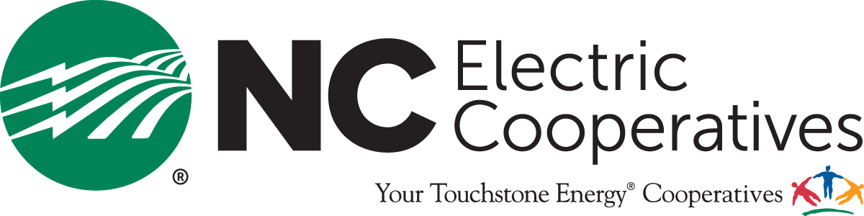

December 17, 2024

Mr. Trey Cash
Greene County Economic Development
229 Kingold Blvd.
Snow Hill, NC 28580

SUBJECT: Letter of support from Pitt and Greene EMC and NC Electric Cooperatives

We are pleased to support Greene County as a partner in your effort to bring jobs, investment, and a higher quality of life to the region. As a non-profit electric cooperative, we have developed a flexible set of resources to deliver a customized service experience for the businesses that help drive economic prosperity in our communities.
The properties you have secured options to become the new Greene County industrial development lie wholly within Pitt and Greene EMC’s service territory. Therefore, our Cooperative Ready Sites program could be utilized to advance the due diligence and marketing of these properties with the goal of attracting new or expanding businesses that our cooperative is prepared to serve.
We are excited to work with you and the citizens of Greene County and stand ready to assist as necessary. Again, thank you for the opportunity to support the economic efforts of the county.

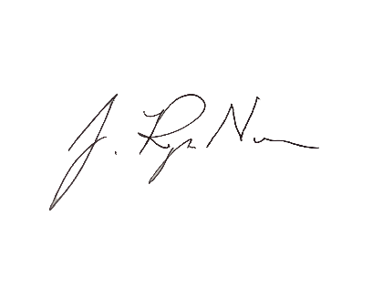
Sincerely,
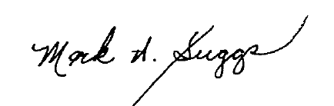

Mark Suggs, CEO
Pitt-Greene Electric Membership Corporation

J. Ryan Nance, Director of Economic Development
North Carolina Electric Membership Corporation

